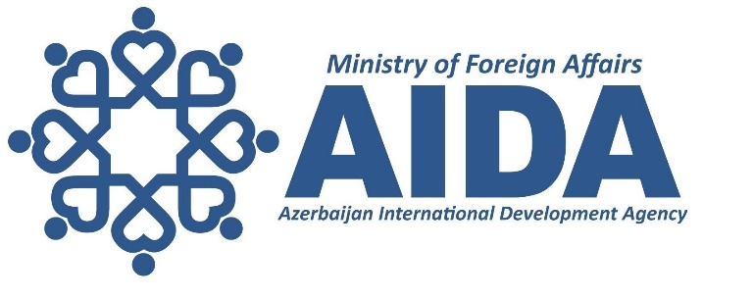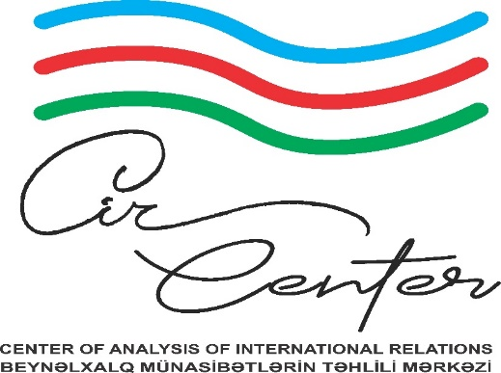

VISITING RESEARCHER PROGRAM 2023

Research Areas

- Heydar Aliyev – National Leader of Azerbaijan;
- Maintenance of international peace and security;
- Bilateral and multilateral relations of Azerbaijan;
- Regional Politics and opportunities for cooperation in the Caspian Basin;
- New realities in the region: prospects for security architecture and sustainable peace in the South Caucasus;
- Conflict resolution: crime of aggression vs. international law in the South Caucasus;
- Regional transport and communications;
- The growing importance of the Middle corridor – Trans-Caspian International Transport Route and the role of Azerbaijan in its realization;
- Importance of Zangezur Corridor in regional and global cooperation;
- Azerbaijan as a reliable energy partner of Europe;
- Role of Azerbaijan in ensuring regional and global energy security;
- Perspectives of sustainable energy transformation and green transition in the Republic of Azerbaijan;
- Azerbaijan’s unique heritage of multiculturalism: unity in diversity;
- Material and cultural heritage of Azerbaijan;
- Deliberate destruction of cultural heritage during the armed conflicts;
- Post-conflict and post-disaster reconstruction and recovery;
- Demographic change in the South Caucasus after the Russian occupation (during Tsarist Russia and the USSR): deportations and relocations;
- Ethnic cleansing in the South Caucasus throughout the 20th century: massacres and mass deportations of Azerbaijanis.

